Shaw Cloud ERP Program

Functional Specifications (Interface)

LOG-INT-18

Oracle ERP Cloud to Logfire Interface: Point Of Sales

# Prerequisites

* Confirm if the ICS Integration process **“SHAW OM PointOfSales From Cloud to LogFire (1.0)”** is activated.

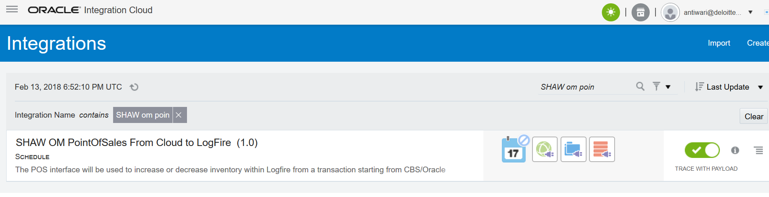

# Run integration

1. Login to ICS using the below URL.

[*https://shawdevics1-a444774.integration.us2.oraclecloud.com/ics*](https://shawdevics1-a444774.integration.us2.oraclecloud.com/ics)

1. Navigate to Integrations

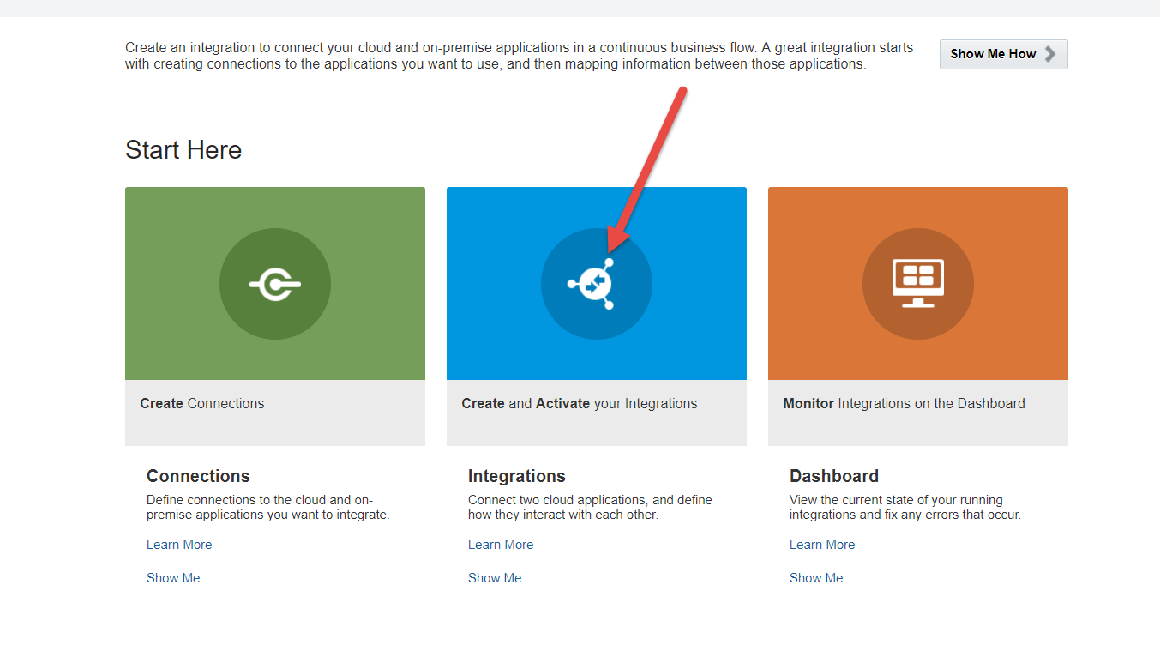

1. Search for “**SHAW OM PointOfSales From Cloud to LogFire (1.0)**”



1. Click on the hamburger icon on the right hand side and select “Submit Now”

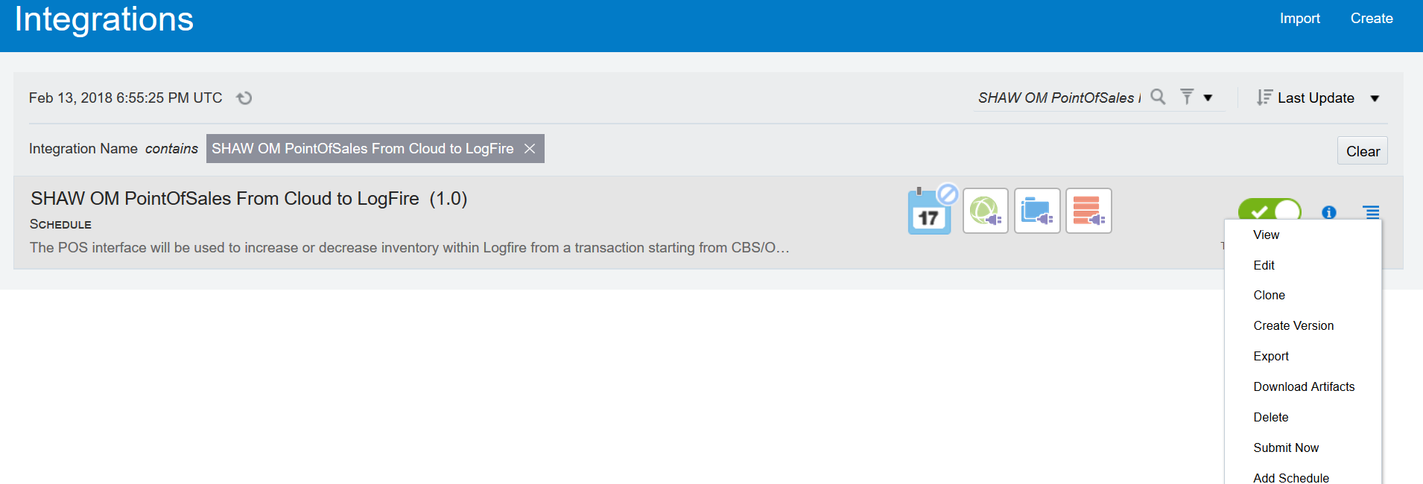

1. You will see a confirmation on the top of the page that the process has been submitted. Click on the request id link

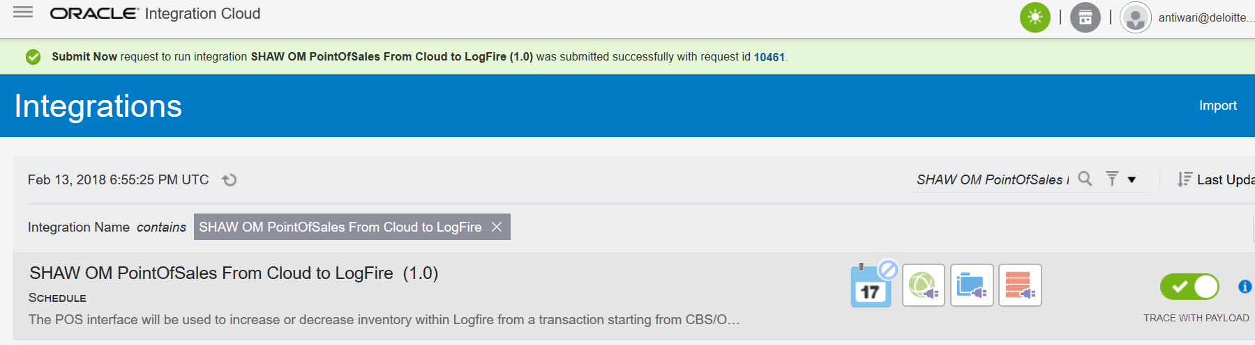

1. Verify if the integration process completed successfully.

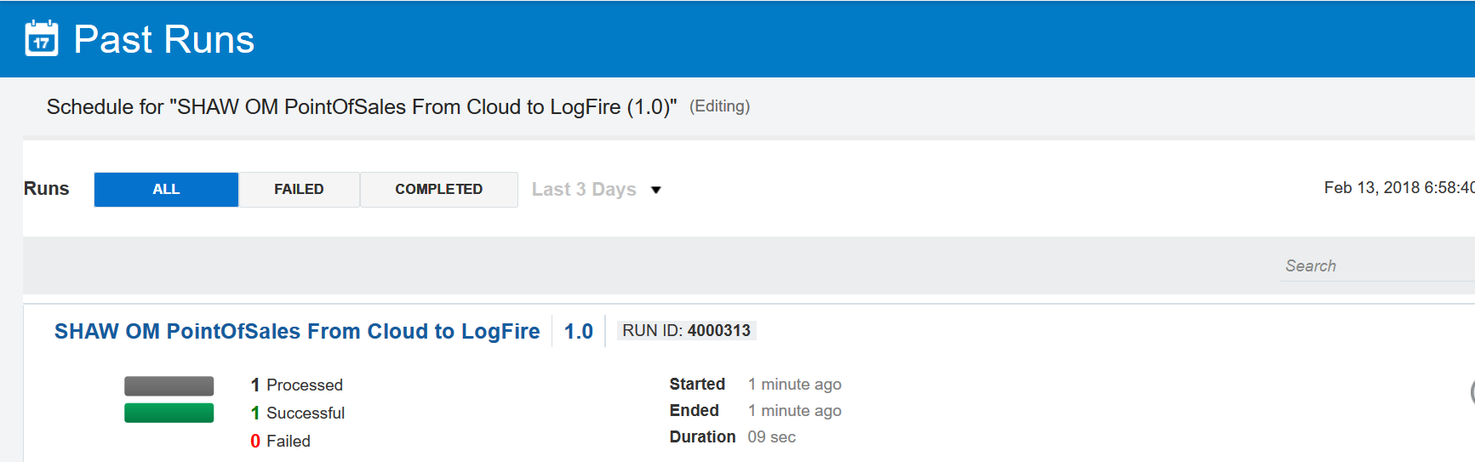

1. Once the process is success. File is generated in Logfire SFTP Server path:/data/LOG-INT-18/Inbound/in

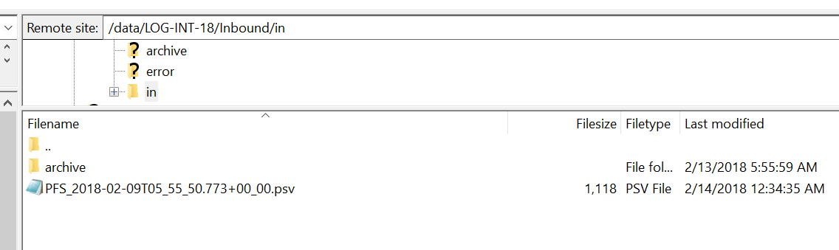

1. Login to Logfire WMS and navigate to Active Inventory and verify whether the Item quantities are increased/Decreased.

